Section A

- Describe what happens when large hydrocarbon molecules are cracked.

__________________________________________________________________________________________
__________________________________________________________________________________________

- Choose which of these is an alkene.
Tick ( ) one box.
- Ethane | 
- Ethene
- Propane

- Give one difference between alkanes and alkenes.

__________________________________________________________________________________________
__________________________________________________________________________________________

- What type of reaction is cracking?
Tick ( ) one box.
- Combustion
- Neutralisation
- Decomposition

- The chemical equations below show some of the reactants and products of different cracking reactions.
- Determine the formula of the missing product in each case.

- C₁₀H₂₂ C₆H₁₄ + _________

- C₆H₁₄ C₂H₄ + __________

- C₁₄H₃₀ C₈H₁₈ + _________

- Highlight all alkanes in one colour and all alkenes in another colour.

Section B

- Crude oil is fractionally distilled. Fractions with larger molecules can then be cracked.

Describe two differences between fractional distillation and cracking.

__________________________________________________________________________________________
__________________________________________________________________________________________
__________________________________________________________________________________________
__________________________________________________________________________________________

- Decane (C₁₀H₂₂) is commonly cracked.

- Determine the formula of the other product formed when decane is cracked.

C₁₀H₂₂ C₂H₄ + ____________

- Name the product with the formula C₂H₄.

__________________________________________________________________________________________

- C₂H₄ is an alkene. Explain how this could be tested.

__________________________________________________________________________________________
__________________________________________________________________________________________
__________________________________________________________________________________________

- Give two conditions used for cracking decane.

__________________________________________________________________________________________
__________________________________________________________________________________________
__________________________________________________________________________________________

- The table below gives some information about fractions of crude oil.

Fraction | Approximate % of crude oil | Approximate % of total demand
LPG | 4 | 6
Petrol | 10 | 25
Kerosene | 16 | 14
Diesel | 20 | 20
Heavy fuel oil |  | 18
 | 28 | 17
- What does LPG stand for?

__________________________________________________________________________________________

- Complete the table by naming the missing fraction and calculating the approximate percentage of crude oil that is made up of heavy fuel oil.

- Identify which of these fractions is the most flammable.

__________________________________________________________________________________________

- Use the information in the table to explain why it is useful to crack hydrocarbons.

__________________________________________________________________________________________
__________________________________________________________________________________________
__________________________________________________________________________________________
__________________________________________________________________________________________
__________________________________________________________________________________________
__________________________________________________________________________________________

- The diagram below shows a chemical reaction.
Compound C
Compound B
Compound A

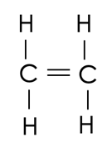
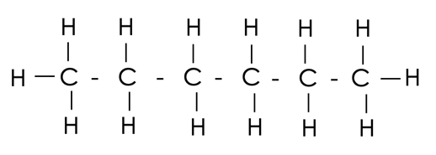
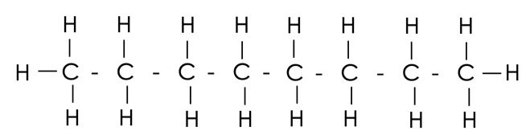

+

- Compounds A, B and C are all what type of compound?

__________________________________________________________________________________________

- What type of chemical reaction is shown by this diagram?

__________________________________________________________________________________________

- Suggest one use for Compound B.

__________________________________________________________________________________________

- Suggest one use for Compound C.

__________________________________________________________________________________________

Section C

- Cracking is used to break long hydrocarbon chains into smaller hydrocarbon chains.
- Cracking takes place under high temperatures. Explain whether cracking is an exothermic or endothermic reaction.
- (HT) C₂₀H₄₂ can be cracked. The equation for the reaction is:

C₂₀H₄₂ C₁₆H₃₄ + 2 C₂H₄

Calculate the mass of C₂₀H₄₂ needed to produce 40 kg of ethene.

Relative atomic masses:
C=12
H=1

